**Resolving Merge conflict in IDE**

Resolving Merge conflict in IDE. This is in-line with what is already detailed from more powerful options from command line mode.

1. Right side view is the one which is committed by Developer B & Developer A has not updated local copy & simulating merge conflict resolution workflow

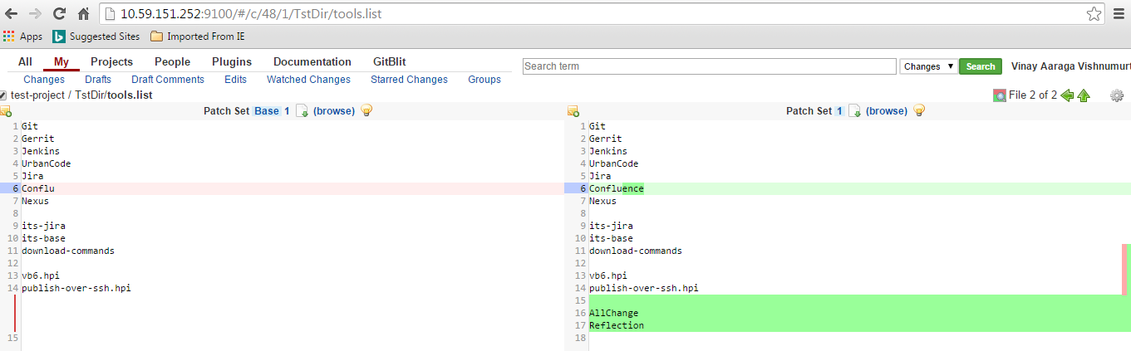

Local copy of repo looks like ( Note : update OR git pull is not done on Developer A )

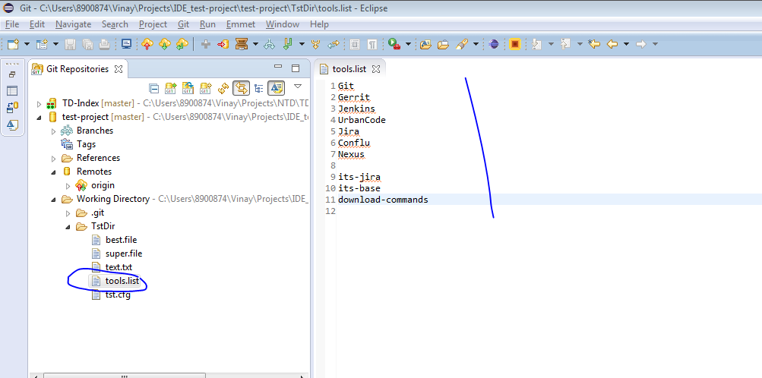

1. Developer A made below set of changes w/o updating local repo, committed & pushed to gerrit ( right click on test-project - > push to gerrit , post commit )

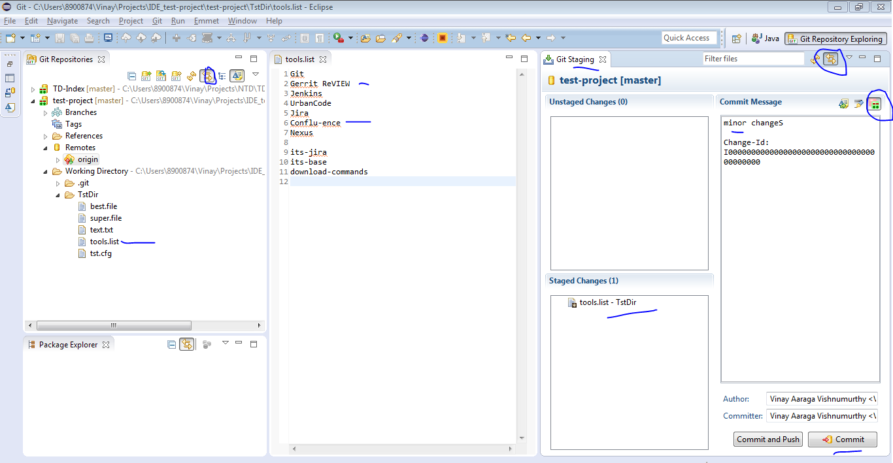

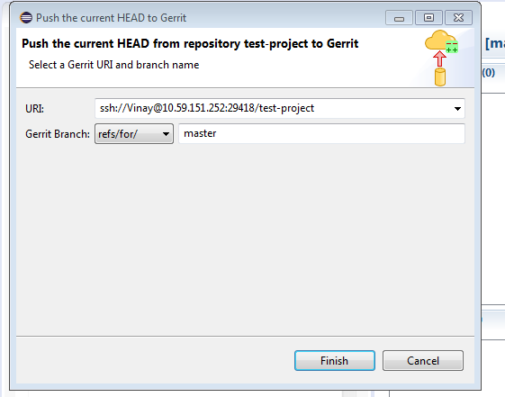

1. Now we see conflict with auto merge & needs manual resolution

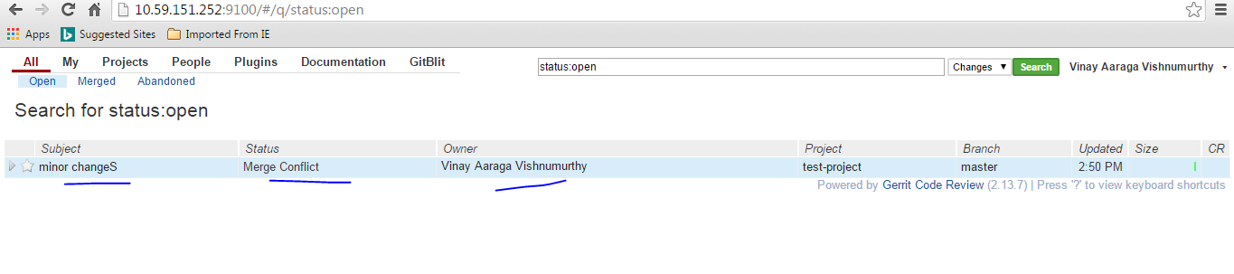

1. Update the repo with pull ing latest  changes. And you need to resolve conflicts on file changed locally. If there are more than one file you need to open that file & resolve. Staging them for commit depends, whether you want to consider or not. It is basically resolving conflict & commit with amend option.

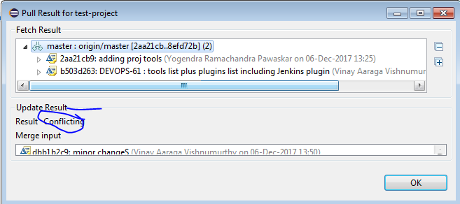

Once updated it shows up conflict. Which you need to resolve. History tells you how it is deviated

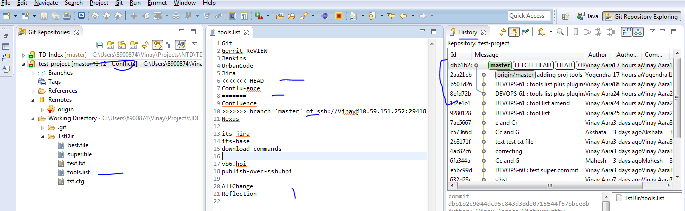

You can initiate ‘Merge tool’ by right clicking on file in Unstaged area & consider options of selection from subsequent window. Or just compare with latest commits from others & resolve yourself.

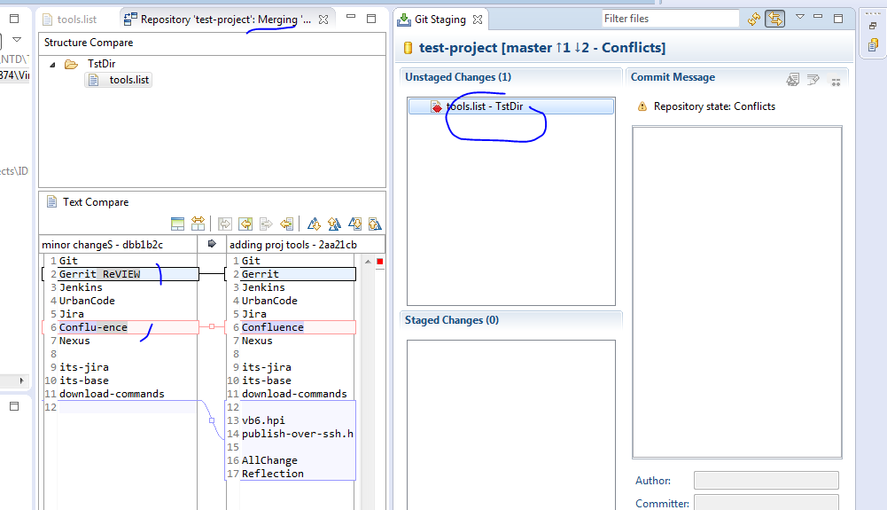

Once you merge, bring it to ‘Staged’. & Commit the previous commit by amending. **Note** : This is mandatory, as it will just upload updated patchset against last commit . Note with ‘Amend ‘ button clicked & seclected like below, it auto populates previously provided comment & change ID AUTOMATICALLY!

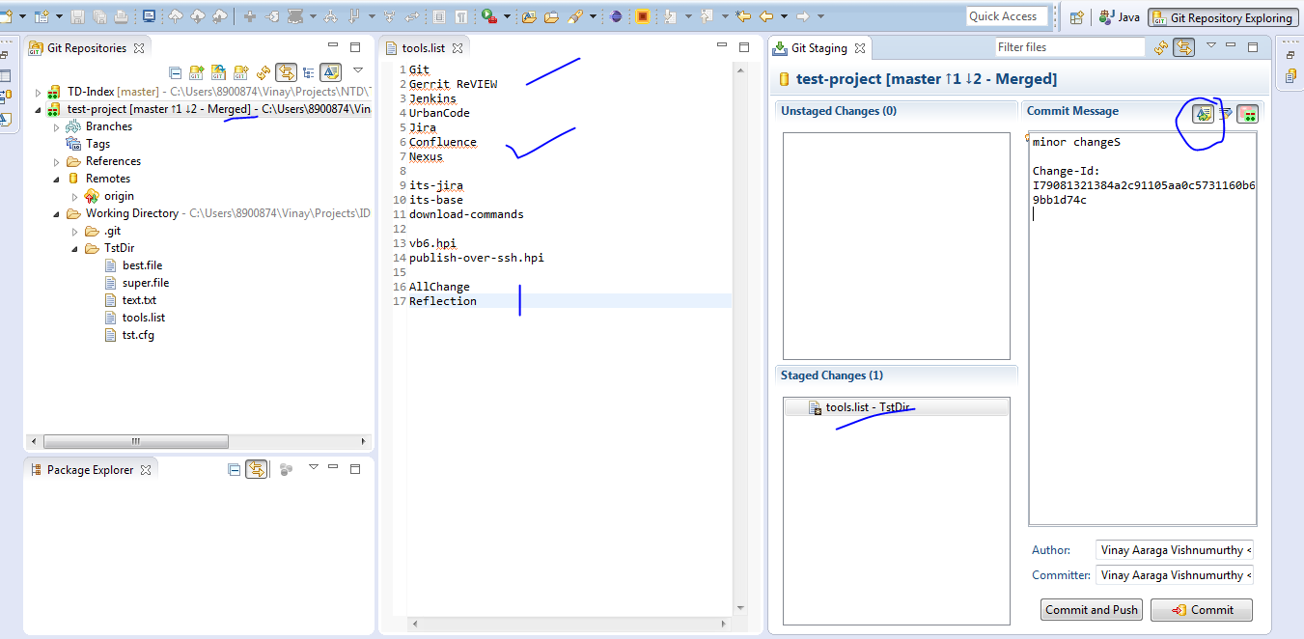

Once committed to local repo, push to remote repo

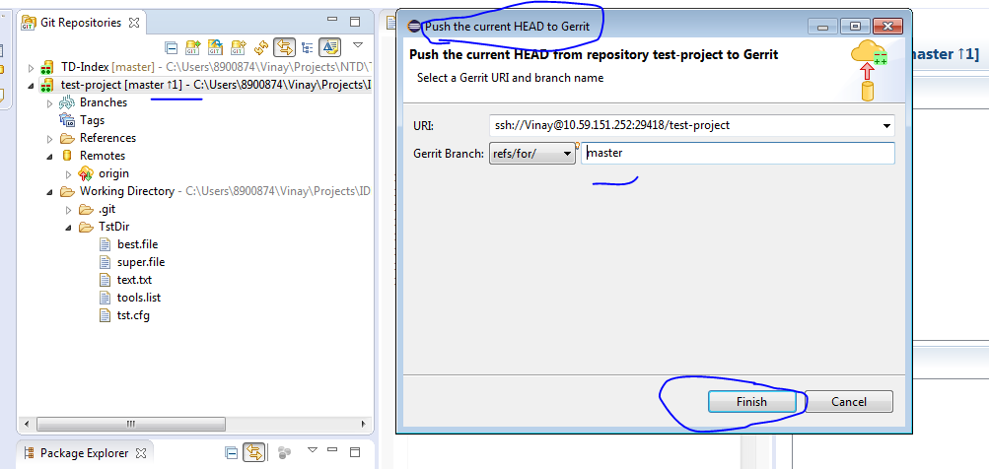

There you go, Conflict is gone ☺ . Now you can view as 2nd Patch set & you can proceed further on asking for review & approval of code for merging to central repo

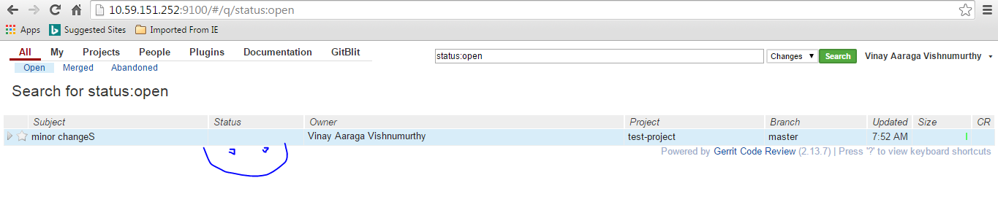

Note on patch set 2 created for same changeID of Gerrit & conflict is gone

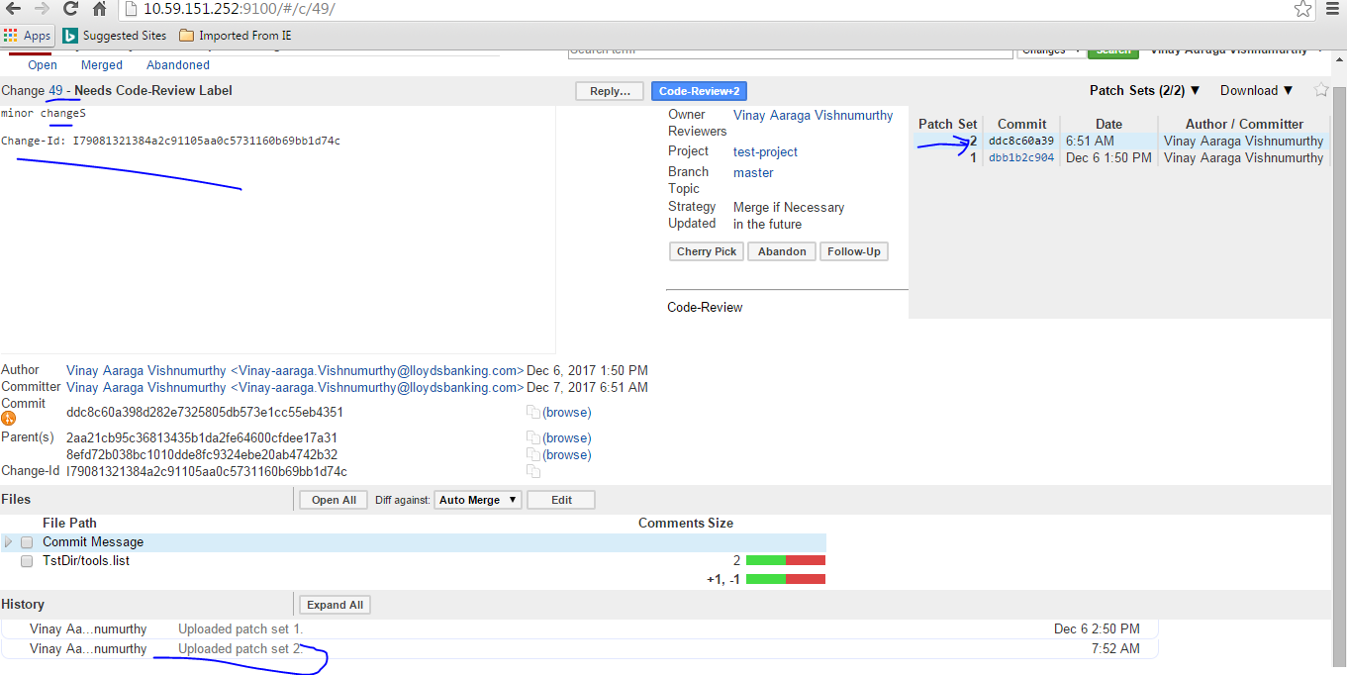

Regards,

*Vi*nay